English language Testing:
1) Generic failure message forces the user to repeat themselves
Observed: After the user provides the symptom (“He has been eating less than usual since 3 days ago”), the assistant replies: “Something went wrong. Please try again.”
Impact: Breaks trust and increases drop-off; also risks losing important clinical context.
Likely cause: LLM/tool call timeout or parsing error without automatic retry, plus no “reprocess last user message” capability.
2) Duplicate question loop (same question asked twice)
Observed: The agent asks “Is Milky still drinking water…” twice in a row, and the user answers twice.
Impact: Feels buggy + wastes turns; can corrupt state (two conflicting answers).
Likely cause: Message dedup/idempotency missing (UI double-submit or backend re-sent), or the slot isn’t getting persisted so the agent thinks it’s still unanswered.

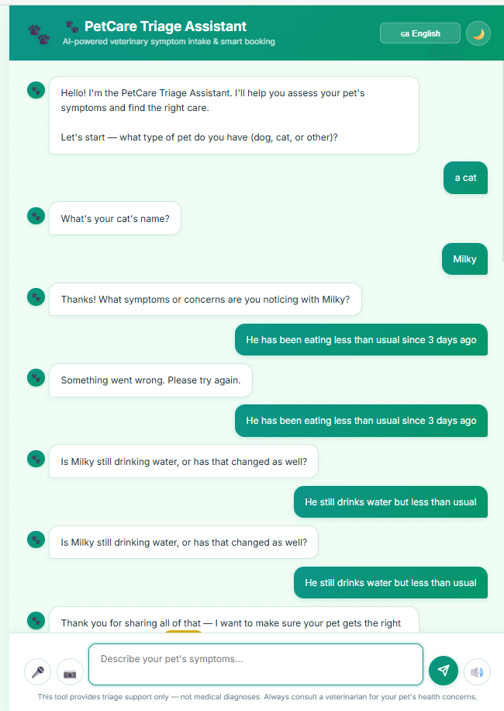
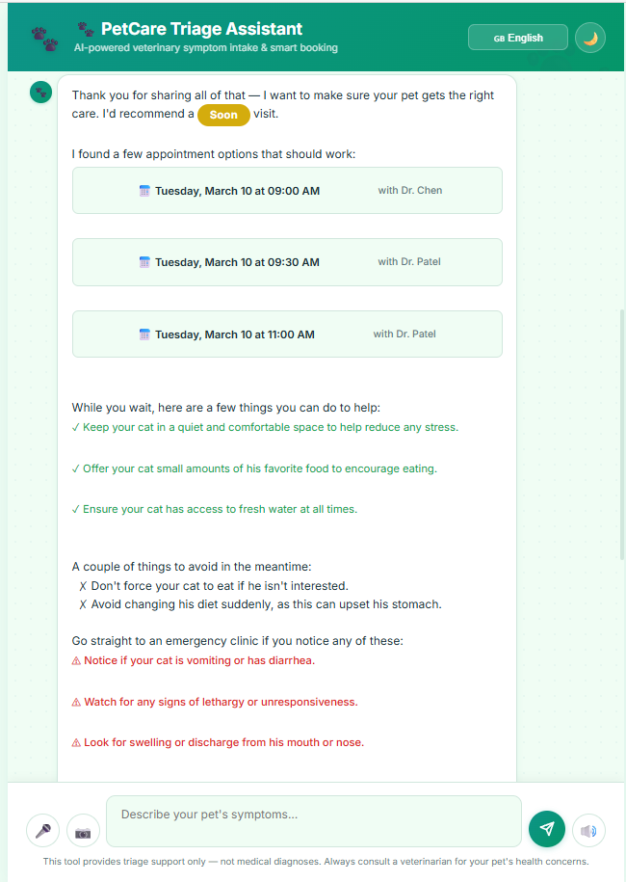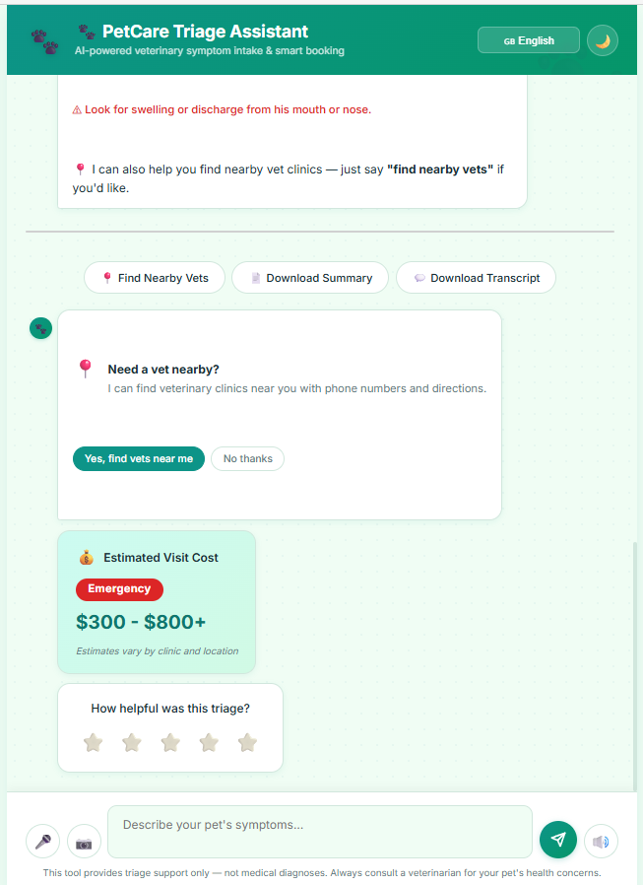

Chinese language testing:
1) Mixed Chinese + English input is not handled reliably
Observed: When the user enters English words inside a Chinese chat (e.g., pet name “Milky”), the agent sometimes fails to recognize the value and repeats the same slot-filling question multiple times (“您的猫叫什么名字？” repeated).
Impact: Frustrating loop; user loses trust quickly.
Example from your screenshot: After “Milky / 他叫Milky”, the system still asks the pet name again.
2) Conversation flow jumps ahead before collecting symptoms
Observed: The agent asks “什么时候开始出现这些症状？” before the user has described any symptoms, and even after the user says “我还没有陈述症状”.
Impact: The questioning feels illogical; increases abandonment.
Example: After confirming name, it jumps directly to symptom onset without first asking “请描述症状”.
3) Chinese response quality drops during advice + appointment booking
Observed: The advice/triage and scheduling message mixes English terms and awkward phrasing (e.g., “Routine 就诊”, English date formatting), and the voice output becomes “not Chinese / weird”.
Impact: Poor UX and lower perceived product quality, especially in voice mode.

